Version 1

**1. If L=1000, Y=1, R=4000 and U=1, choose a value of X. What is the total transmission time in the circuit switch network and packet switched network? (3 marks)**

Answer: $T_{p}=\frac{4000X-4H+5P}{4\left(P-H\right)}$ $T_{C}$ =2.25s

When I use packet switched method. Set up the packet routing delay is 0.2seconds.

The transmission time of circuit switching mode is assumed to be $T_{C}$. The transmission time of packet switching mode is assumed to be $T_{p}$.

According to the transmission time formula of circuit switching:

$$T_{C}=U+\frac{L}{R}+Y$$

According to the formula, the change of Max packet length(P), Header Length(H) and Packet routing delay(X) will not affect $T_{C}$.

According to the transmission time formula of packet switching:

$$T_{p}=NX+\frac{L+NH}{R}+Y$$

And formula N (N round up to the nearest integer)

$$N=\frac{L}{P-H}$$

Finally, Obtained the formula

$$T_{p}=\left(\frac{L}{P-H}\right)X+\left(\frac{L}{P-H}\right)\frac{H}{R}+\frac{L}{R}+Y$$

According to the meaning of the question L = 1000, Y = 1, R = 4000, U = 1. Substitute into the formula to get Time expression for $T_{p}$:

$$T_{p}=\frac{4000X-4H+5P}{4\left(P-H\right)}$$

And $T_{C}$ =2.25s

**2. Take the same inputs as Question 1. If P=125 and H=25, under what values of X would packet switching give better performance than circuit switching? Give your answer to 5 decimal places. (3 marks)**

Answer: X < 0.09375s

Change Max packet length and header length to 125 and 25 respectively.

It has been learned in the first question that the transmission time of circuit switched will not change with the variables in the second question, so it is still 2.25s. Therefore, it is only necessary to judge the value of packet routing delay. The transmission time of packet switched is less than that of circuit switched.

According to the $T_{p}$ formula

$$\left(\frac{L}{P-H}\right)X+\left(\frac{L}{P-H}\right)\frac{H}{R}+\frac{L}{R}+Y=T_{p}<2.25s$$

Make the transmission speed of packet switching faster than that of circuit switching, and bring T < 2.25s into the packet switching formula. X < 0.09375s was obtained.

Therefore, when x is less than 0.09375s, the transmission speed of packet switching is faster than that of circuit switching.

**3. Use the same values as in Questions 1 and 2, and set X such that the total transmission times are equal for each case. Now increase L by 2 bits. Why does the total transmission time increase much more in packet switch than in circuit switch? (2 marks)**

When X = 0.09375, the transmission speed of the two methods is the same.

When other values remain unchanged, increase the value of message length by 2bits. The obtained transmission times are shown in the figure below.

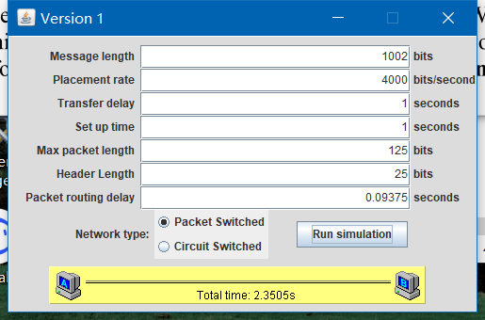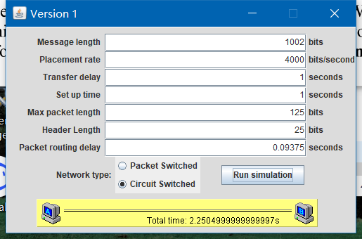

According these figure, the total transmission time increase much more in packet switch than in circuit switch.

In terms of formulas, the formulas of the two transmission methods are deformed respectively

Get $T_{p}$ according to the formula in question2 is

$$T_{p}=\left(\frac{X}{P-H}+\frac{H}{\left(P-H\right)R}+\frac{1}{R}\right)L+Y$$

And $T_{C}$ is

$$T_{C}=U+\frac{1}{R}L+Y$$

Comparing the coefficient of L in the two formulas, we can see clearly that the value of $\left(\frac{X}{p-H}+\frac{H}{\left(p-H\right)R}+\frac{1}{R}\right)$ in $T_{p}$ must be greater than $\frac{1}{R}$ in $T_{C}$. When L increases, the total transmission time increase much more in packet switch than in circuit switch.

**4. Using the same values as in Question 3, increase L by a further 2 bits. What is the increase in total transmission times from Question 3 for each kind of network? Why is the increase the same for circuit switch and packet switch in this case? (2 marks)**

Add 2 bits to L (message length) on the basis of question3, and the value obtained is

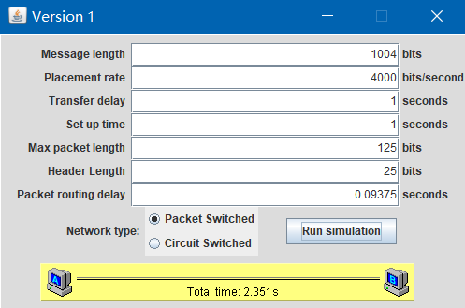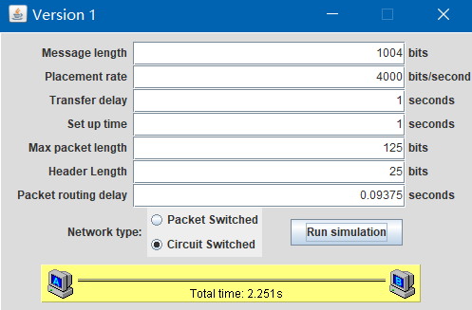

It can be seen that the transmission time of both methods has increased by 0.0005s. Hypothesis Δ L represents the L value of the last time minus the L value of the previous time.

ΔL=L2-L1

Deform the equation in question3 to obtain that the packet switch transmission time is:

$$ΔT_{p}=\left(\frac{X}{P-H}+\frac{H}{\left(P-H\right)R}+\frac{1}{R}\right)ΔL+Y$$

The transmission time of circuit switch is:

$$ΔT_{c}=U+\frac{1}{R}ΔL+Y$$

It can be found that U and Y are fixed values. and ΔL coefficients are also fixed values. And because ΔL increases by 2bits, so $ΔT_{p}$ and $ΔT_{c}$ is the constant value. That is, as long as the packet switch is guaranteed ΔL and in circuit switch ΔL is equal and all other values are adjusted to the appropriate value. Then can make $ΔT_{p}$ = $ΔT_{c}$.

**5. Based on your observations of the tandem network, discuss whether circuit switching or packet switching would be more suitable for this type of network. As part of your answer, consider if adding additional nodes to this network would impact on your choice. (2 marks)**

The circuit switching method is more suitable for two users to communicate with each other, because the advantage of channel monopoly makes the transmission delay small and the transmission speed fast. In principle, there is no out of order problem.

However, adding new nodes is no longer suitable for this method, because the channels of the two nodes are exclusive, and adding new nodes will slow down the communication speed. The packet switch method is more suitable for multiple nodes to communicate with each other.

Version 2

**6. If L1= L2= L3=1000, Y=1, R=4000 and U=1, what is the total transmission time for each message in each of the circuit and packet switched cases? (3 marks)**

Answer: $T_{p}=\left(\frac{3000}{P-H}+1\right)\left(X+\frac{P}{4000}\right)+2$ $T_{C}$ =9.75s.

According to note $T_{c}$ is three times $T_{C_{1}}$ ( $T_{C_{1}}$ is $T_{c}$ in version1)plus three times transfer delay.

$$T_{C_{1}}=U+\frac{L}{R}+Y$$

The result is the formula of multiple nodes in version 2(n is the number of instances).

$$T_{C}=nT_{C_{1}}+nY$$

According to the meaning of the question, n=3, $T_{C_{1}}$ =2.25s, Y=1.

Bring into the formula to get Circuit switching time is

$T_{C}$ =9.75s.

The formula ($T_{p}$) can be obtained according to the information in the note,

$$T_{p}=X+\left(\frac{P}{R}\right)+Y+3N\left(X+\frac{P}{R}\right)+Y$$

N is:

$$N=\frac{L}{P-H}$$

The formula $T_{p}$ is:

$$T_{p}=\left(\frac{3L}{P-H}+1\right)\left(X+\frac{P}{R}\right)+2Y$$

Message length = 1000, Transfer delay = 1, set up time = 1, Placement rate = 4000, Max packet length = P, Header length = H, Packet routing delay = X.

The formula $T_{p}$ is:

$$T_{p}=\left(\frac{3000}{P-H}+1\right)\left(X+\frac{P}{4000}\right)+2$$

**7. Take the same inputs as Question 6. If P=125 and H=25, under what values of X would packet switching give a faster total delivery time for all three messages (i.e. time until last bit of last message arrives) than circuit switching? Give your answer to 5 decimal places. (3 marks)**

Answer: X<0.21875s

Therefore, in order to meet the requirement that the transmission time of packet switched is less than circuit. In other words, $T_{p}<T_{C}$.

According to question6, we can find $T_{C}$ has nothing to do with packet routing delay, so $T_{C}$ = 9.75s, so need required $T_{p}$ <9.75s.

Bring value in the formula to get

$$\left(\frac{3L}{P-H}+1\right)\left(X+\frac{P}{R}\right)+2Y{=T}_{p}<9.75s$$

Get X is:

X<0.21875s

Therefore, when X <0.21875s, the transmission time of packet switched is faster than that of circuit switched.

**8. Use the same input values as in Question 7, and set X=0.2. Now increase L1 by 4 bits, L2 by 4 bits and L3 by 2 bits. In the packet switched network, which message has the smallest total transmission time? Explain why. (2 marks)**

Answer: L3 has the shortest total transmission time.

The transmission principle of packet switched is to judge the message length first, and then send the message in the order of short to long. If the message length is the same, it shall be in line order. If the message length is different, send the shortest message first, and then send it in sequence from short to long according to the message length.

When L1 = L2 = 1004 and L3 = 1002, N needs round up to the nearest integer. Therefore, at this time.

$$\frac{L}{P-H}=N=11$$

Therefore, there are 11 groups in L1, L2 and L3.

In packet switching, the transmission time of each route before G is the same, but the transmission from node G to the receiver is transmitted one by one. Therefore, in order, it will be transmitted to the receiving end of the shortest L3 line, then to the receiving end of L1 line, and finally to the receiving end of L2 line. Therefore, the last three messages must be transmitted to the L3 line first, and L3 must receive all message contents first. Next is L2 and then L1 reception ends, the whole transmission process ends.

Therefore, the total transmission time of L3 is the shortest.

**9. Use the same input values as in Question 8. Again increase L1 by 4 bits, L2 by 4 bits and L3 by 2 bits (from the values in Question 6). In the circuit switched network, which message has the smallest total transmission time? Explain why. (2 marks)**

Answer: The total message transmission time of L1 is the shortest.

Because in the circuit switched transmission, after the message is sent and received, the transmission of a line will end. And proceed to the next line. In other words, the line is exclusive during transmission. Each line is transmitted independently. So according to Time formula of $T_{C}$

$$T_{C}=nT_{C_{1}}+nY$$

Since each line is independent, the time of each line can be calculated separately, even if n = 1

$$T_{C}=U+\frac{L}{R}+2Y$$

Therefore, the route time calculation formula is:

$$T_{n}=T_{\left(n-1\right)}+T_{c} (T_{0}=0)$$

Bring in L1 = 1004, L2 = 1004 and L3 = 1002 respectively to obtain

T1=3.251s

T2=T1+3.251s=6.502s

T3=T2+3.2505s=9.7525s

It can be seen that T1 < T2 < T3.

Therefore, T1 has the shortest time and L1 has the shortest total message transmission time.

**10. Based on your observations of the start network, discuss one negative issue that you have observed with this type of network. Discuss whether changing this type of network (i.e. by changing the configuration of nodes to a ring/bus or fully connected network) would address the issue you identified, as well as introduce any additional issues. (3 marks)**

Star type network structure is simple and easy to manage. However, there is only one route. When there is a problem with this route, all communications cannot be transmitted. Therefore, the burden of the central node is heavy, which is not conducive to the expansion of the line. The consequences of the failure are quite serious.

Ring / bus / fully linked networks can solve this problem. Compared with star networks, these networks have certain fault recovery ability, but the advantages and disadvantages of each structure are different.

The bus network structure is also a simple network structure. There is no central node, which will not affect the transmission due to a node failure, and has high reliability. However, if the backbone fails, the whole network will be paralyzed.

Ring network structure is a network structure with simple network construction, simple structure and easy management. However, it has too many nodes, so the transmission efficiency is not high, it is not easy to expand, and the transmission direction is one-way.

The fully connected network has strong reliability and stability, but its structure is complex and its cost is very high.